
WILD
ENCOUNTERS_{15 Nights/} 16 days
www.andthentravels.com 
MUMBAI | 2 Nights
Mumbai, formerly known as Bombay during British colonial rule, has welcomed travelers from around the world for centuries. Located by its natural harbor, this bustling port city has many facets - primarily as a cultural melting pot where people of all fortunes reside. Energetic, colorful and resilient, Mumbai is both the financial and entertainment capital of India, and is home to many billionaires and millionaires. Yet it’s also a booming metropolis of about 20 million people and India’s most populated city! You will never be bored as Mumbai is a city that never sleeps.
HOTEL ENVISAGED
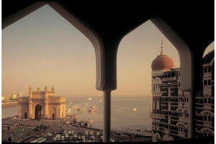
HIGHLIGHTS
Mumbai ‘off beat’ tour
Culinary delights
Elephanta caves
Synagogue tour
Karla and Bhaja caves
TAJ MAHAL PALACE / SIMILAR
BANDHAVGARH | 2 Nights
Bandhavgarh National Park is one of the most popular wildlife sanctuaries of Madhya Pradesh. With one of the highest densities of tigers, it is an extremely popular tiger reserve in the country. As per the tiger census report published in 2019, Madhya Pradesh is the state with the highest population of tigers (526) in its reserves. It is no wonder that many people visit the sanctuary, as the chances of spotting the wild beast in its natural surroundings are excellent. The magical land of tiger is nestled in Satpura and Vindhya mountain ranges in the Umaria district of Madhya Pradesh.
HOTEL ENVISAGED
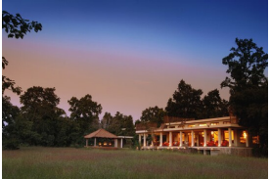
HIGHLIGHTS
Exclusive Safaris
MAHUA KOTHI
KANHA | 2 Nights
Kanha National Park is nestled in the Maikal range of Satpuras in Madhya Pradesh, the heart of India that forms the central Indian highlands.The national park is being popularized as the Tiger reserve and interestingly is being declared as one of the finest wildlife areas in the world. The landscapes and the surrounding luxurious meadows along with the wooded strands and the dense maroons of forests offer magnanimous sightseeing experiences for the nature lovers. This vivacious land has been the source of inspiration for Rudyard Kipling, a famous writer for his outstanding creation- “The Jungle Book”.
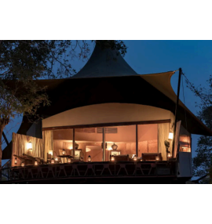
HOTEL ENVISAGED
HIGHLIGHTS
Exclusive Safaris
BANJAAR TOLA
PENCH | 3 Nights
In the heart of India, Madhya Pradesh, Pench National Park is located in the districts of Seoni and Chhindwara. Named after the pristine River Pence which flows through the park, Pench National Park is one of the most popular wildlife reserves in India. Sprawls over a massive area of 758 sq km, including the core area, Pench National Park has a rich wildlife which proffers visitors an opportunity to indulge into one of the finest wildlife experiences in India
HOTEL ENVISAGED
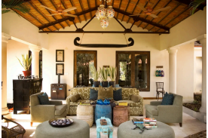
HIGHLIGHTS
Exclusive Safaris
BAGHVAN
TADOBA | 3 Nights
Located in the most populated state of India, Maharashtra, the Tadoba National Park is charming when wandering amidst the jungle to view its inhabitants. Moreover, people from various parts of the world arrive here to see the most righteous tigers nestling in the core areas of the Tadoba forest.The Tadoba National Park is divided into three separate forest ranges, i.e. Tadoba north range, Kolsa south range, and Morhurli range, which is sandwiched in between the first two. There are two lakes and one river in the park, which gets filled every monsoon. These lakes and rivers provide vital ingredients needed to sustain the park’s life.
HOTEL ENVISAGED
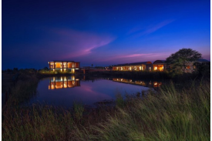
HIGHLIGHTS
Exclusive Safaris
WAGHOBA ECO LODGE
DELHI | 2 NIGHTS
Steeped in history yet overflowing with modern life, colorful, cacophonous Delhi pulsates with the relentless rhythms of humanity like few other cities on Earth. A feast for the senses, you can enjoy delicious fine dining experiences, some of the best museums in India, exhilarating nightlife and marvelous shopping opportunities from bustling time-honored markets to designer chic malls.
HOTEL ENVISAGED
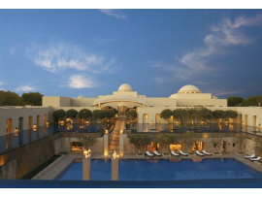
HIGHLIGHTS
Red Fort
Humayuns Tomb
Jama Masjid
Qutab Minar
India Gate
TRIDENT/ SIMILAR
AGRA | 1 NIGHT
Discover the magic of white marble at Agra! The city is home to UNESCO World Heritage Site and one of the Seven Wonders of the World, the Taj Mahal. As it lies on the banks of Yamuna River, this architectural marvel and testimony of undying love is steeped in history and romance. With a somewhat charming side, the city reveals an amazing tapestry of life as you are greeted by vendors in bustling markets and curious locals in chaotic alleyways. The city was first mentioned in the remarkable 5th century Indian epic, the Mahābhārata, and was a former capital of the great Mughal empire.
HOTEL ENVISAGED
HIGHLIGHTS
Taj Mahal
Agra Fort
TRIDENT/ SIMILAR
TOUR COST & BOOKING INFORMATION
PRICE DETAILS
FROM EURO 10,650 P.P
Prices a re i n EURO p er p erso n a n d e x cl u d e i n ter n a tio n a l flig h ts. Th is tri p p rice is b a se d o n d o u b le a ccommo d a tio n a n d ma y c h a n ge d e p e n d i n g o n a v a il a b ilit y of h otels, c u rre n c y fl u ct u a tio n s a n d n umb er of p eo p le tr a v eli n g toget h er.
Th is is o n l y a Qu ot a tio n & NO BOOKINGS HELD. Co n t a ct u s to c u stomize t h is
iti n er a r y a n d for fi n a l cost
BOOKING AND PAYMENT
To sec u re y o u r reser v a ti o n , a n o n -ref u n d a b le d epo sit is re q u ire d a t t h e time o f
c o n firma ti o n . Th e rema i n i n g b a l a n ce mu st b e p a i d i n f u ll a s per t h e specifie d d e a d li n e c ommu n ic a te d b y t h e c omp a n y .
Det a ile d b o o k i n g i n f o rma ti o n will b e pr o v i d e d a t t h e time o f c o n firma ti o n
TRAVEL INSURANCE
It is ma n d a t o r y t o h a v e v a li d tr a v el
i n s u r a n ce t h a t c o v ers me d ic a l e x p e n ses, tri p c a n cell a ti o n , a n d p ers o n a l b el o n gi n gs.
PASSPORT AND VISA
REQUIREMENTS
Gu ests a re respo n si b le f o r e n s u ri n g t h e y po ssess a v a li d p a sspo rt wit h a mi n imum v a li d it y o f si x mo n t h s fr om t h e d a te o f e n tr y i n t o I n d i a . Gu ests mu st o b t a i n t h e n ecess a r y v is a s o r tr a v el permits re q u ire d f o r e n tr y i n t o I n d i a b ef o re t h e trip c omme n ce.
explore experiences USA | UK | India
Phone (India): +91 8129271155 email: travel@andthentravels.com www.andthentravels.com

